SIMULATION EXPERIMENT – 1
❖ Simulation-Based Electromagnetic Analysis of TEM, TE and TM Propagation Modes in Microwave Transmission Structures
➔ Objectives of this Experiment:
1. To develop electromagnetic simulation models for TEM, TE and TM propagation modes in suitable microwave transmission structures.
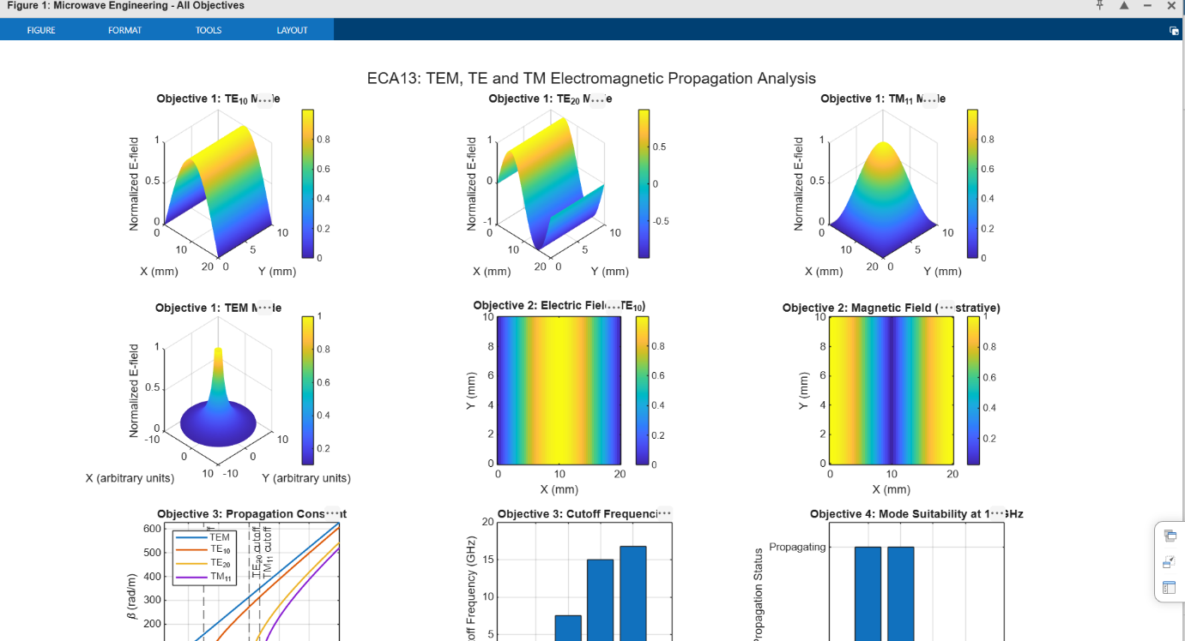
2. To visualize and analyze the electric-field and magnetic-field distributions associated with different prop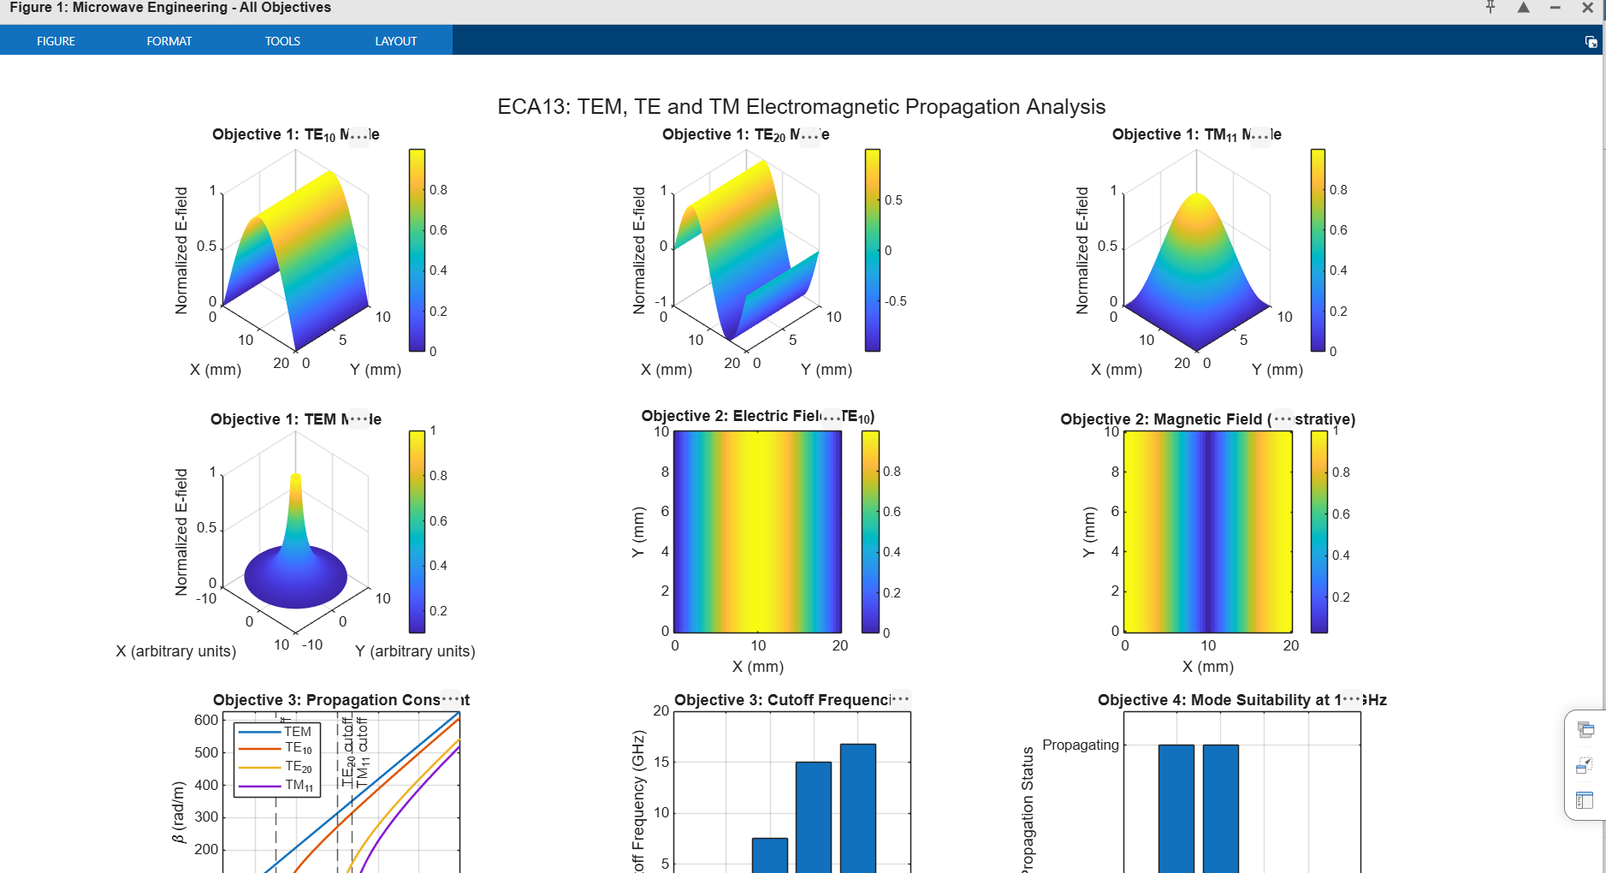agation modes.
3. To determine the cutoff frequency, propagation constant and field characteristics of selected TE and TM modes.
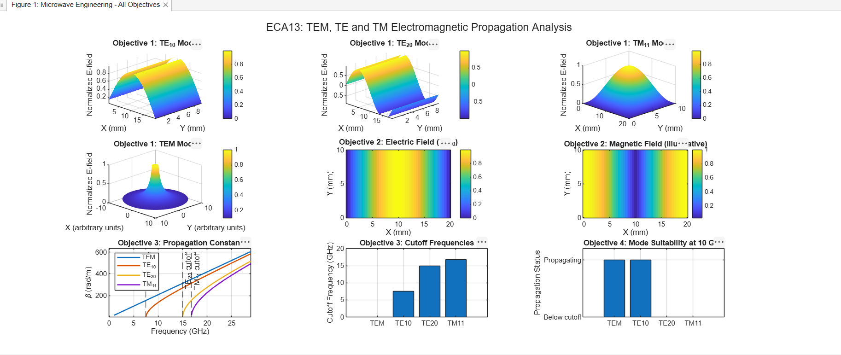
4. To compare the propagation behavior of different modes and identify their suitability for practical microwave transmission.

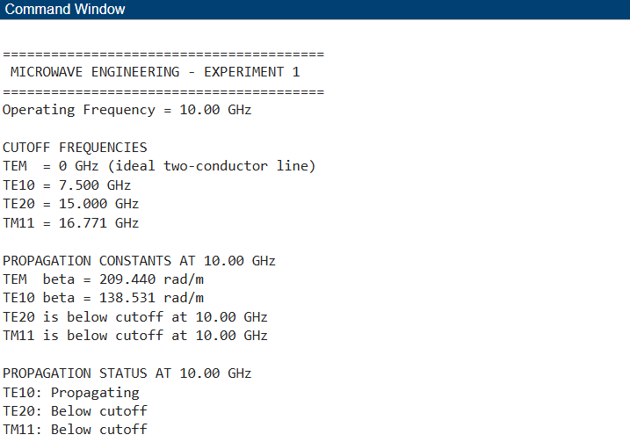
Result:
The MATLAB simulation demonstrates the differences between TEM, TE, and TM propagation modes. The 3D surface plots illustrate the normalized electric field distributions, while the cutoff-frequency and propagation-constant graphs show how wave propagation depends on frequency and waveguide dimensions.

